Rural Changemaker Request for Proposal (RFP)

GENERAL INFORMATION
Background
Interact for Health works to ensure that people in our region have a just opportunity to live their healthiest lives, regardless of who they are or where they live. We advance health justice through grantmaking, collaboration, learning, convening, and engagement. Interact for Health is an independent foundation in 20 Ohio, Kentucky, and Indiana counties. In 2024, Interact for Health launched its Rural Investment Strategy, which included $1M in investments in strategic grantmaking, community participation, and event sponsorship opportunities. Interact for Health is reaffirming its investment in its Rural Strategy in 2025, including through the Rural Changemaker Grant outlined below.
RFP Goal
To promote health and well-being in the rural regions in Interact for Health’s service area by providing funding to address grassroots work in Ohio, Indiana, and Kentucky related to the vital conditions for health and well-being –the resources we all need to thrive.
RFP Overview
The communities served by Interact for Health have distinct strengths and attributes that make residents proud to call this area “home.” Yet, in many communities, there are also underlying problems that present significant barriers to health and well-being. As a result, many in our region do not have the vital conditions for good health in the places where they live, learn, work, and play.
For example, some rural areas have access to affordable, nutritious food—a vital condition for good health. Others seem to be cut off from the supply of affordable produce, which increases the risk for developing a condition like heart disease, the leading cause of death in our region. Place affects diet, which affects health.
Other aspects of the places where people live matter, too. The vital conditions for health and well-being are the building blocks all people and communities need to thrive and experience well-being. They include:
- Belonging and Civic Muscle (e.g., connections with neighbors, volunteering)
- Thriving Natural World (e.g., public green spaces, clean water)
- Basic Needs for Health and Safety (e.g., preventative care, violence prevention)
- Humane Housing (e.g., affordable housing, resources to prevent housing crisis)
- Meaningful Work and Wealth (e.g., labor representation, equitable wages for workers)
- Lifelong Learning (e.g., outside classroom engagement, nontraditional learning models)
- Reliable Transportation (e.g., community rideshare, public transit)
Rural communities already demonstrate the vital conditions for health through innovative, community-driven efforts every day: Local farmers’ markets improve access to healthy, affordable food while strengthening social connections; local housing coalitions mobilize neighbors to meet needs for safe and stable housing; after-school programs spark and sustain students’ interests and learning. Yet despite these examples and others like them, there are also instances in which the Vital Conditions for Health are not fully, fairly, or consistently available.
Deficits in the vital conditions for health are not the fault of local communities or the people who live there. Rather, they are rooted in collective decisions, both public and private, that have historically denied rural communities access to resources and undermined rural residents’ power to pursue solutions that are locally relevant and effective.
This funding effort aims to support grassroots, locally-led efforts to build — or amplify —community efforts to strengthen one or more of the vital conditions for health. Our population of focus with this grant is rural communities, but Interact for Health’s other priority populations (Black, Hispanic, LGBTQ+, Children in Low-Income Families) must also be meaningfully engaged.
Eligibility Criteria
Applicants must:
- Be a public or private nonprofit or governmental organization.
- Provide services in at least one of Interact for Health’s rural counties in Ohio, Indiana, or Kentucky (see “Definitions” below).
Organizations that are not nonprofits or governmental entities may still seek funding through fiscal sponsorship. A fiscal sponsorship is a relationship between a 501(c)(3) tax-exempt nonprofit organization (the sponsor organization) and a charitable project or program that does not have a tax-exempt status (the sponsored organization).
Grantee Requirements
Depending on the request, awarded grantees may be expected to:
- Participate in grantee meetings up to three times yearly to share their work and learning with other grantees and Interact for Health.
- Participate in evaluation and learning activities for the grant and part of the overall initiative.
Funding Details
- Type of Grants: Grants may be awarded for project-based or general operating support, depending on the proposed efforts and based on the needs and desires of the grantee.

- Size of Grants: Grant size and length will vary based on the scope of the effort. We anticipate they will range from $10,000 - $70,000 for 12 - 18 months.

- Other Support: These grants are intended to allow us to learn alongside partners and continue to inform our Rural Investment Strategy. Opportunities for technical assistance and additional support to partners will be implemented on an as-needed basis by grantees and topics that arise during the learning sessions.

  - Additional support may include but is not limited to hiring consultants, one-on-one grantee support, and group training sessions.

Proposal Selection Criteria
Proposals for the Rural Changemaker Grant should:
- Serve at least one of Interact for Health’s rural counties.
- Address a challenge or underlying inequity identified by the community related to the Seven Vital Conditions for Health.
- Plan, develop, implement, and/or sustain a solution that engages community members in the effort, including leadership and decision-making power.
- Meaningfully engage with Interact for Health’s Priority Populations.
Rural Community Council
The rural region (Indiana, Ohio, and Kentucky) has a dedicated advisory council composed of community members. Each member either lives or works locally in one of our rural counties and is interested in the long-term health of their community. This council acts as a review and scoring body for Rural Changemaker grantmaking, advising on projects and their potential impact on rural communities.
Timeline
Release RFP | July 8th, 2025
Rural Community Office Hours | August – September, 2025
RFP Due | September 8th, 2025, 5 p.m.
Rural Community Council Review Complete | September 26th, 2025
Site Visits | October 6th – 17th, 2025
Grants Awarded | October 30th, 2025
*An introductory webinar and community sessions will be offered to explain the funding opportunity and answer any questions from community members and organizations interested in applying.
Community Office Hours
Program staff will be available at the following locations during the times below to answer any questions about the RFP or your proposed ideas.
Clermont County Public Library- Batavia  (180 S Third St., Batavia, OH 45013) | August 21  1:00 – 4:00 p.m.
Main Branch Public Library- Lawrenceburg  (150 Mary St, Lawrenceburg, IN 41040) | August 28  1:00 – 4:00 p.m.
Pendleton County Public Library- Falmouth  (801 Robbins Ave., Falmouth, KY 41040) | September 4  1:00 – 4:00 p.m.

Proposal Submissions
Applications will be accepted twice annually. They must be submitted for this round by September 8th at 5 pm via Interact for Health’s online grants management system. To begin the application process or to access a PDF of the required application questions, please visit the Open Funding page of our website. If you have an open grant or have received a grant from Interact for Health in the past two years, your email address may already be registered in the system. For assistance with the application process, please get in touch with our Director of Grants Management, Kristine Niergarth, at kniergarth@interactforhealth.org.
Site Visits
Before making final selections for funding, Interact for Health staff will conduct a site visit, either virtual or in person, with the potential grantee. Representatives from collaborating organizations are required to attend the site visit. This meeting allows Interact for Health staff to hear more about the proposed project and ask any clarifying questions. Site visits for this round will be conducted in October following the review and selection process. Applicants will indicate their preferred timeslot during the application process.

Site visit topics will include:
- General discussion of your proposed project and budget

- The population of focus for the project

- Any disparities that exist and how this project plans to address them

- Community engagement tactics

- Collaborating partners and organizations or those you intend to engage

- Your organization's journey around justice, diversity, equity and inclusion

- What “success” for this project will look like

Questions
For any questions, please contact Senior Program Manager of Community Engagement (Rural), Caitlin Bentley-Thayer, at cbentley@interactforhealth.org or 606-226-0025.
Definitions
- Community Power: The ability of communities most impacted by inequity to act together to voice their needs and hopes for the future and to collectively drive structural change, hold decision-makers accountable and advance health equity.

- Grassroots Organization: Local, regional, national or international efforts and organizations led by everyday people who are closest to an issue. Grassroots Organizations take a “bottom-up” approach and begin with community-based initiatives that grow outwardly to include other strategic partners.

- Health Justice takes equity a step further by changing systems in order to achieve sustainable and equitable change for the long-term. It recognizes the barriers that stand in the way of optimal health and works to remove them. Health justice is addressing root causes through power building, policy and system change.

- Mental Health is health. It shapes how we cope with stress, overcome challenges, build relationships and enables us to value and engage in life. Simply put by someone in our community, it means being good with yourself. At Interact for Health, we define mental health broadly to mean the promotion of mental health, resilience and wellbeing; the treatment of mental and substance use disorders; and the support of those who experience and/or are in recovery from these conditions, along with their families and communities.

- Movement Building is the process of mobilizing individuals, organizations, and communities to create a collective force aimed at addressing systemic health and social inequalities and promoting equitable outcomes for the benefit of all. It involves the coordination of education, policy, and community engagement to build support and initiate the necessary changes to generate the outcomes that will benefit the community.

- Policy Change: A policy change attempts to change public laws, regulations, rules, mandates (public policy) or budgets/funding.

- Rural: Interact for Health defines “rural communities” for our grantmaking purposes by utilizing intersectional criteria focused on population density and a historic deficit in resources.

  - Lower population density, compared to other areas.
  - Historically under-resourced, compared to other areas.
    - Federal and state dollars lower.
    - Local city/ township investment and tax base are lower.
    - County tax base is lower compared to other areas.
  - Fewer local resources than other areas.
    - Fewer local nonprofits.
    - Few medical facilities.
    - Fewer emergency responder resources.
    - Fewer public school systems and districts.

- Rural Regions: Interact for Health defines the following counties in these states as our rural regions:

  - Indiana Region
    - Dearborn County
    - Franklin County
    - Ripley County
    - Ohio County
    - Switzerland County
  - Kentucky Region
    - Bracken County
    - Gallatin County
    - Grant County
    - Pendleton County
  - Ohio Region
    - Adams County
    - Brown County
    - Clermont County
    - Clinton County
    - Highland County

- Systems Change: A system change attempts to shift the way broader systems (e.g., health, public safety, local government) make decisions about policies, programs and the allocation or use of resources.

- Urgent Services are the services that anyone under adversity would need to temporarily regain or restore their health and well-being. While they are necessary, historical ways of thinking about overall health and well-being have led to an over-investment in urgent services and an under-investment in vital conditions.

- Vital Conditions for Health and Well-Being are the conditions in which people are born, grow, work, live and age, and the wider set of forces and systems that shape our daily lives. The seven vital conditions, listed below, are required for people and communities to reach their full potential and to create an equitable, thriving future for ourselves and generations to come.

  - Belonging and Civic Muscle
  - Thriving Natural World
  - Basic Needs for Health and Safety
  - Humane Housing
  - Meaningful Work and Wealth
  - Lifelong Learning
  - Reliable Transportation

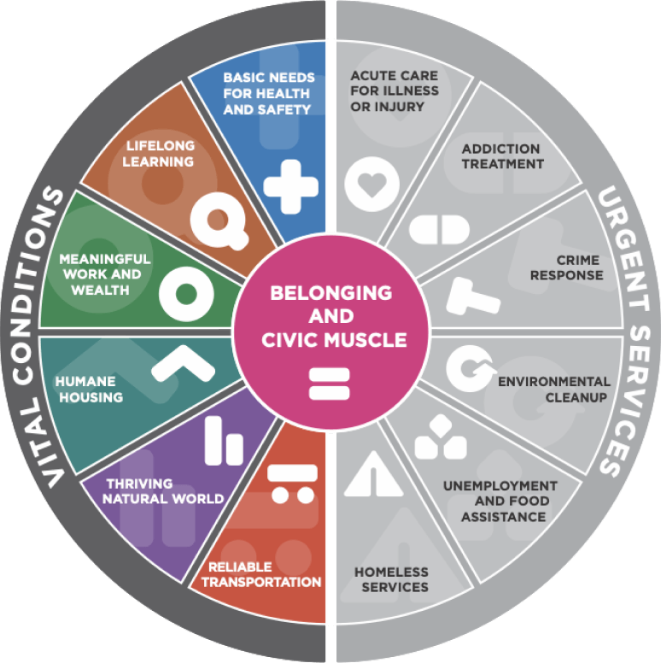
Vital Conditions vs. Urgent Services – additional information and context can be found here: https://rippel.org/vital-conditions/

